VM (Bastion)

For connecting the VM we are opening the RDP Connection with the help if IP Address. RDP Will always run on 3389.

With out RDP if you want to connect to VM we can enable Bastion we need to enable Bastion subnet and bastion Vnet

Connectivity for bastion will be 443 port https will connect to VM Via browser the public Ip will be hidden here (TLS-

Transport Layer security ) 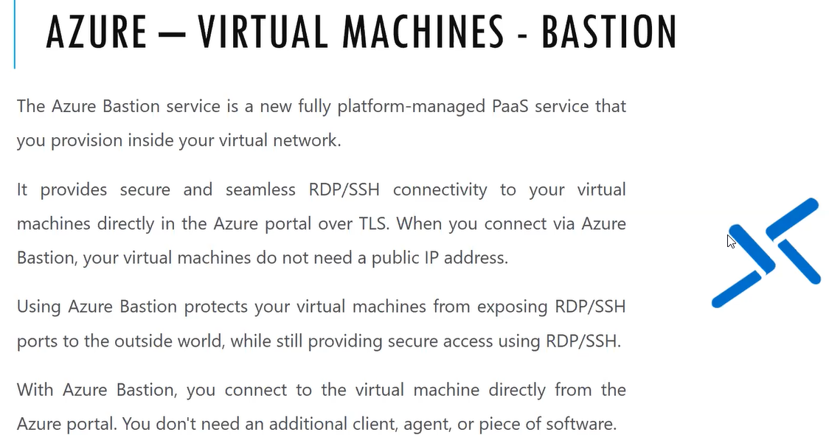

Bastion is also called Jump box/Jump Server / bride box. From client to our office network there will be one connection/bridge will made with that same connection/bridge from office to remaining employees will be connected.

Once we connect to VNET via Bastion all the VMs are connected to Bastion

It will 15 minutes to deploy. Once we enabled Bastion service on the https there will be end point created in the URL the Azure will provide the service

If you click on the connect then new tab will be opened so that RDP connection will be established or SSH Connection will be established

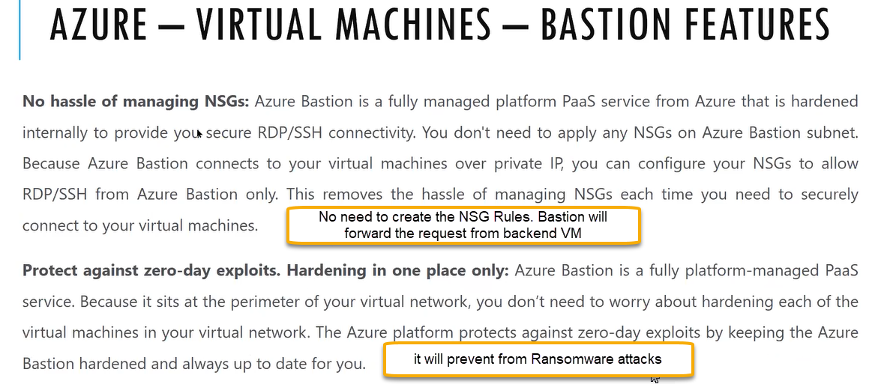

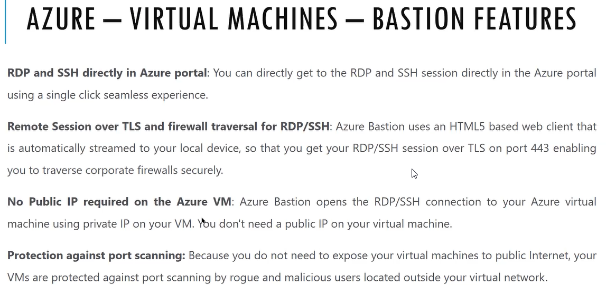

First we need to create the Bastion subnet in VNET level

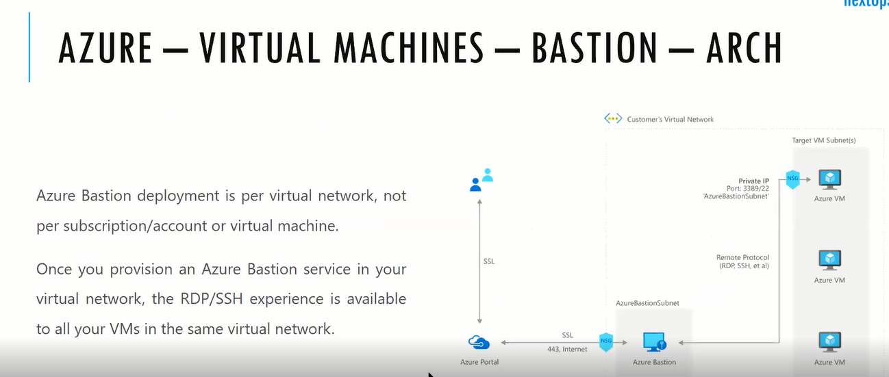

If End user wants to access the bastion then he must have access to portal which is minimum requirement

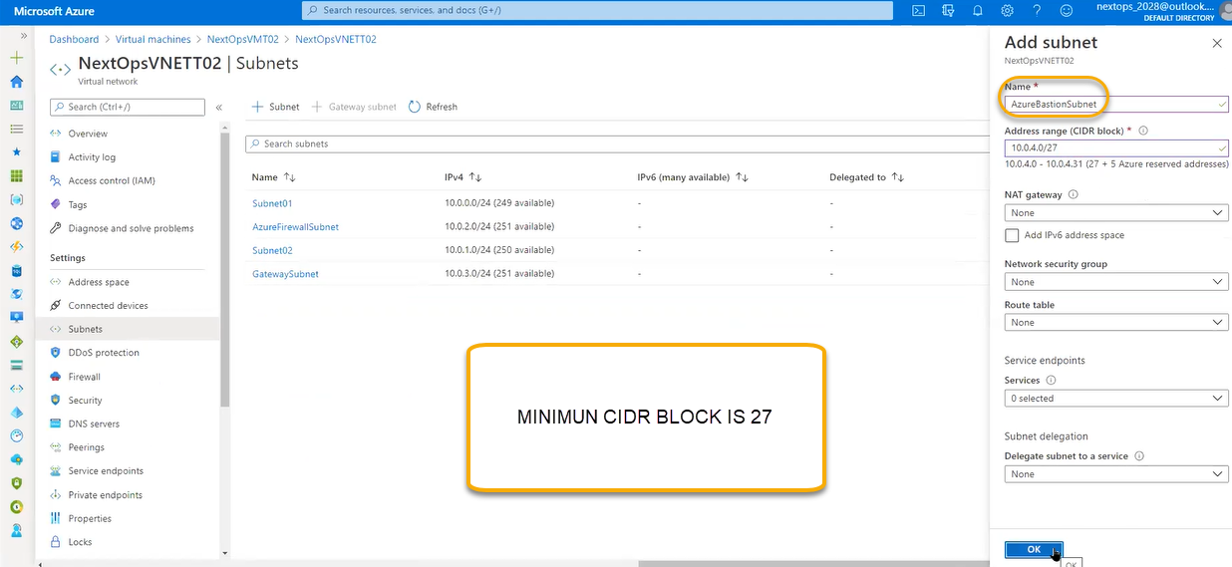

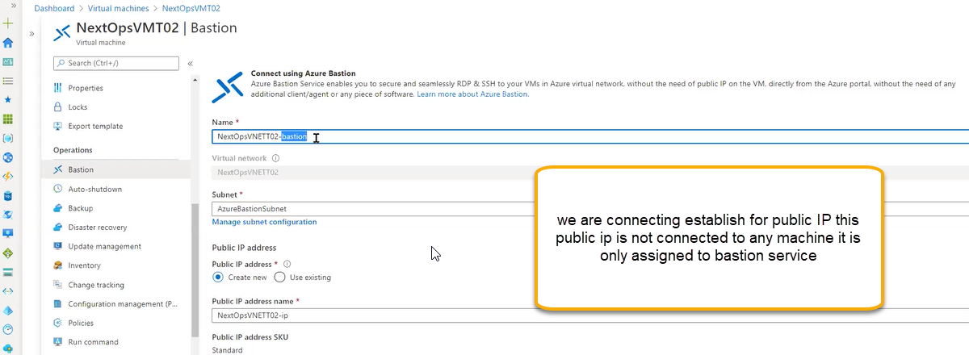

Once you click on the create it will take 15 minutes. Connectivity options will come browser

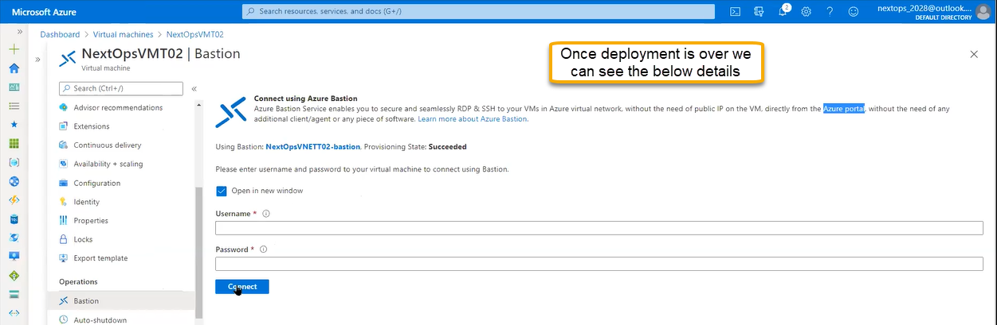

We need to power on (start the VM machine)

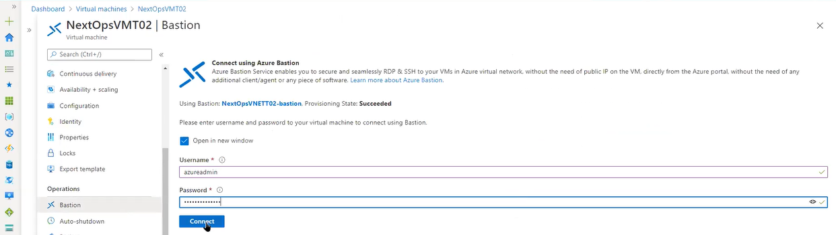

Once we click on the connect it will open another tab



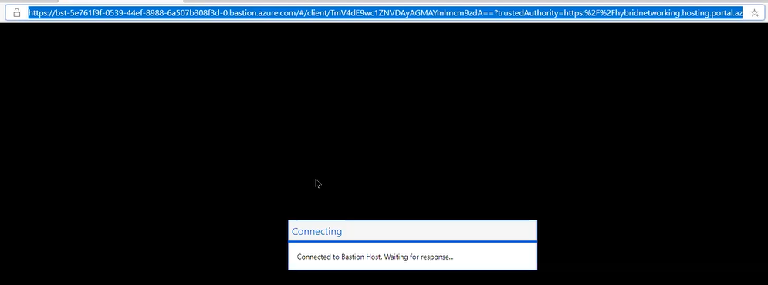

RDP session will be opened in another tab

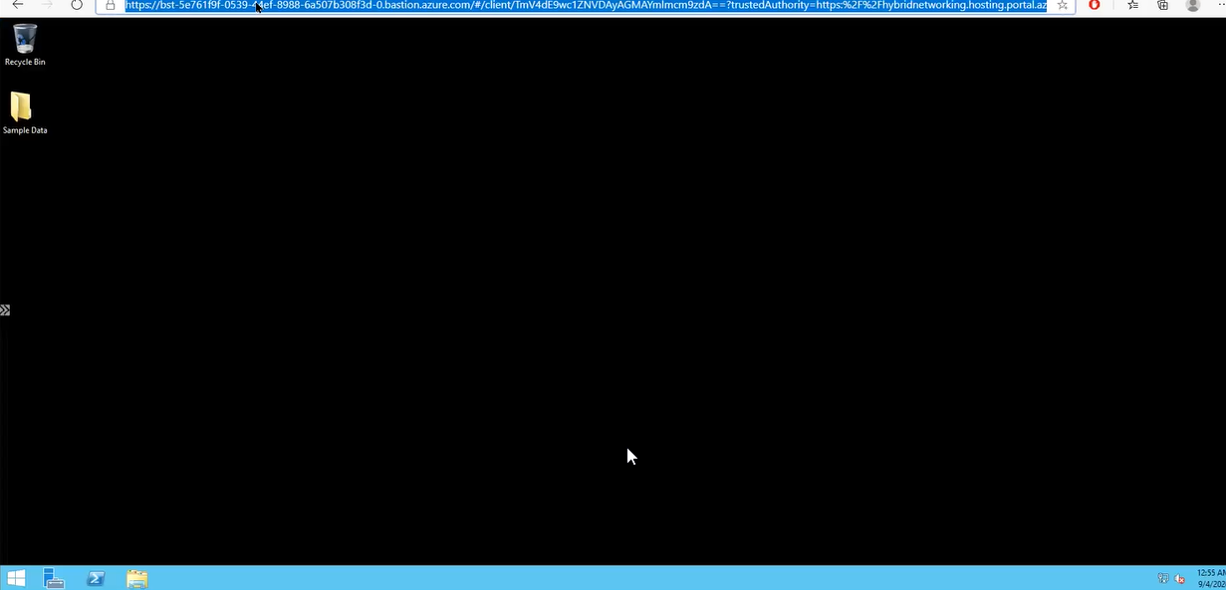

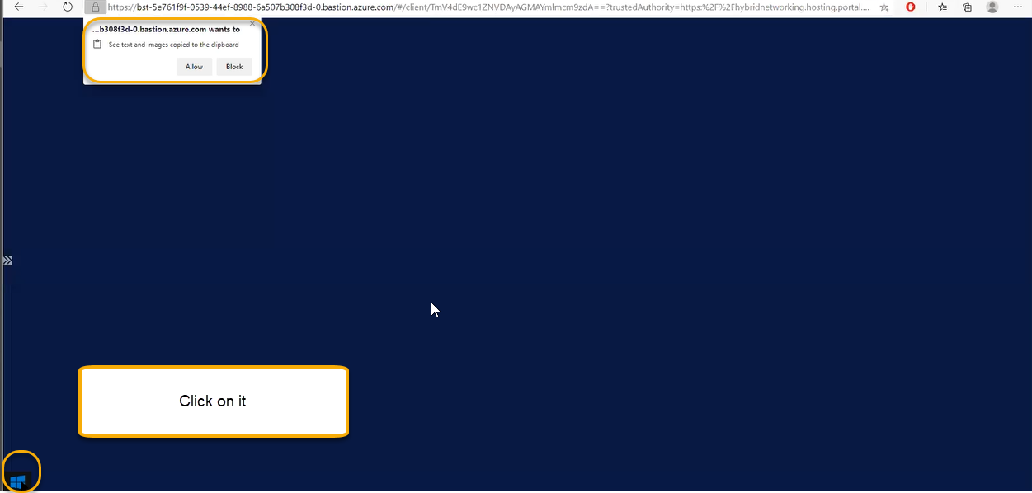

If you try to login the same URL in Another browser or another user, we will get the error



We can assign one VM to one Bastion and for other VMS we do not need Bastion then we can configure it we need to follow the document process. And if you create another VM and we can connect the VM via Bastion from the broswer

Auto- Shutdown

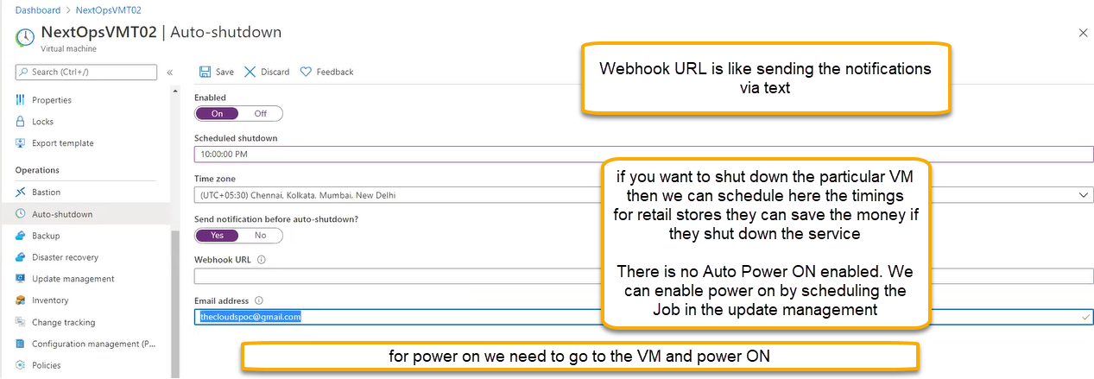

Update Management (updating the systems we will use update management)

Microsoft will release the patch every month on second Tuesday that is called Patch Tuesday for world wide distribution applicable to licensed version. If we are patching/updating for all the systems is called data center maintenance for system

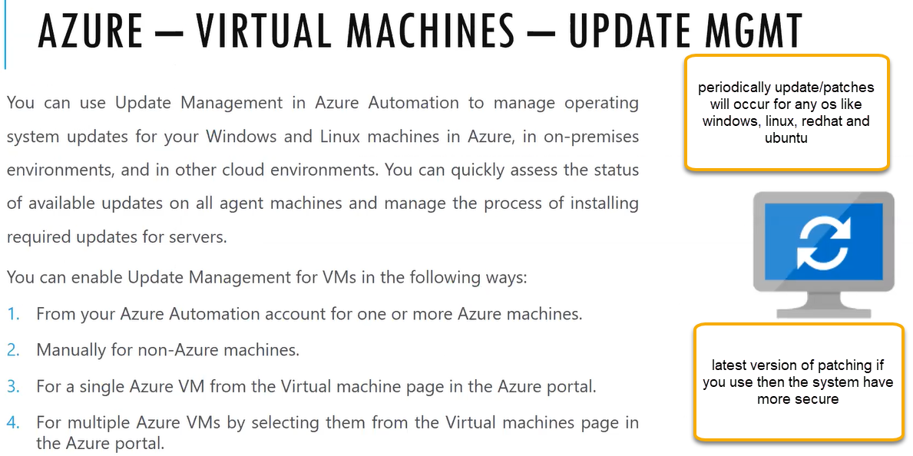

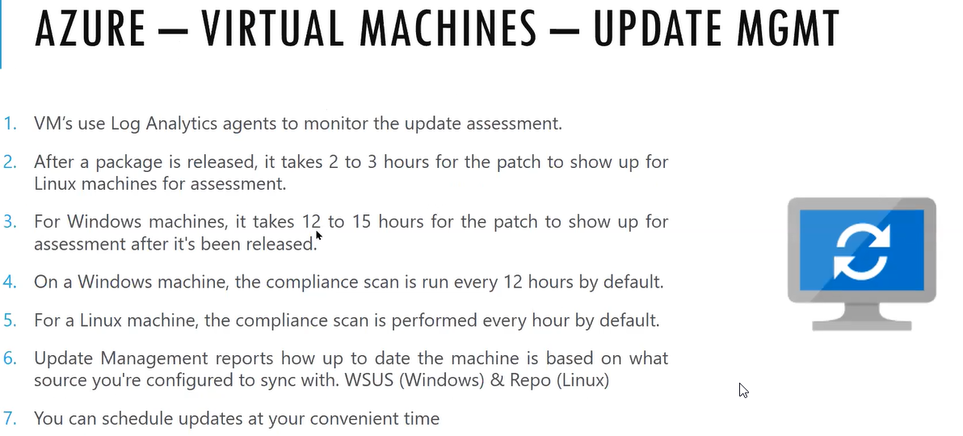

We need to associate with Automation account to get the latest updates

Periodically running the jobs there will be resource

We can update the Non-Azure machines

For managing the patching we need automation account and also we need log analytics work space creation

In Azure monitoring there is one component which will send the information for log analytics ( it’s a kind of database). The azure monitor will read the log analytical workspace like CPU Usage, RAM utilize or any updates missing from log analytics work space azure will tell this

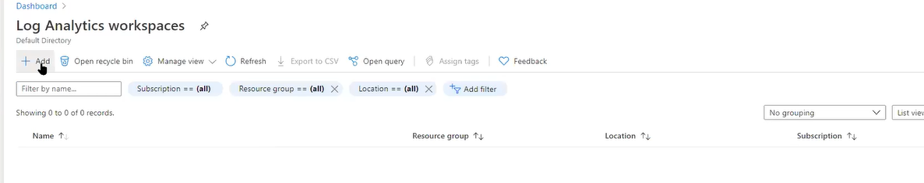

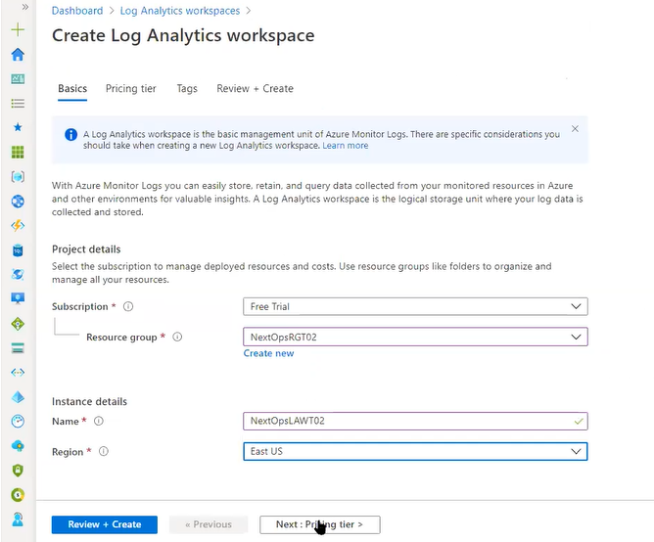

Click on Next and next and create

However we still see the error in the VM Level

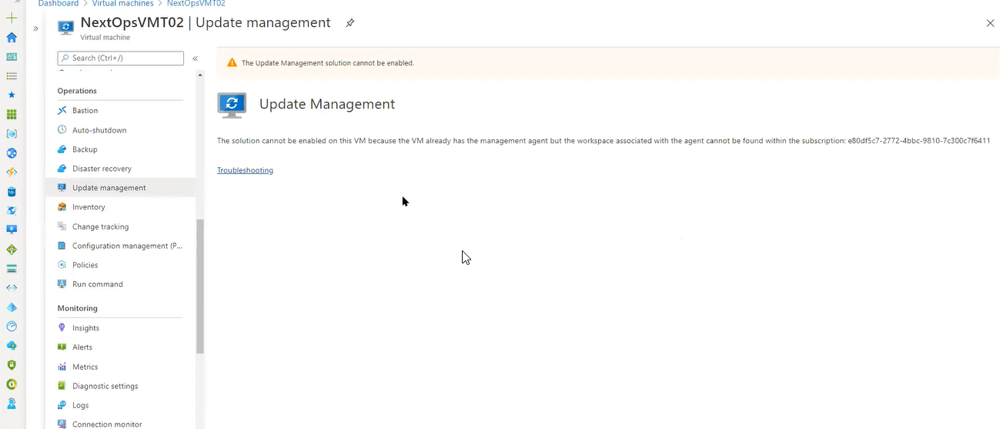

Previously we call it as Operations Management Suite now it is renamed as Monitor

We need to onboard the VM in the log analytics work space

In the below screenshot the VM will be automatically shown in the Virtual machines tab

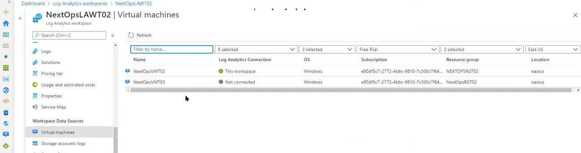

If you see any error for the VM like it is connected to another workspace ( that work space is already deleted ) then disconnect that work space and then connect it again as shown below screenshots

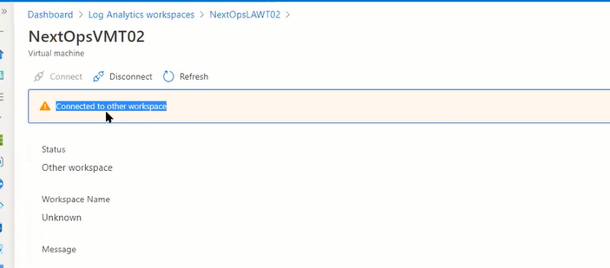

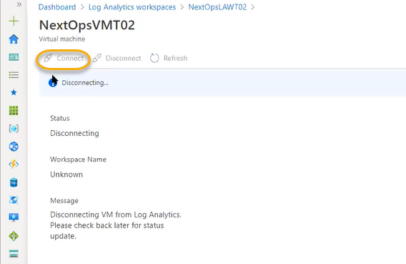

Update management , inventory , change tracking depends on work space Now we see below we don’t see any error under update management. And it as asking the options to select

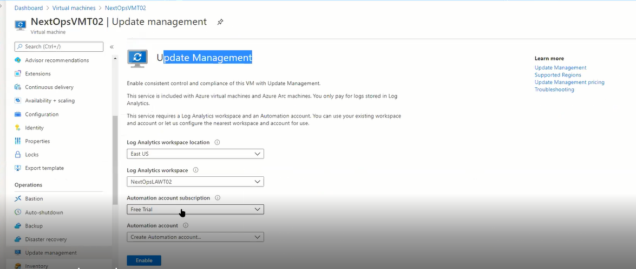

After enabling the options will be greyed out. Please refer the screenshot below. We don’t need to create the Automation account once we click on the Enable button the automation account will be automatically created

the requirements for update managememt, inventory and change tracking is enabling the log analytics workspace and automation account.

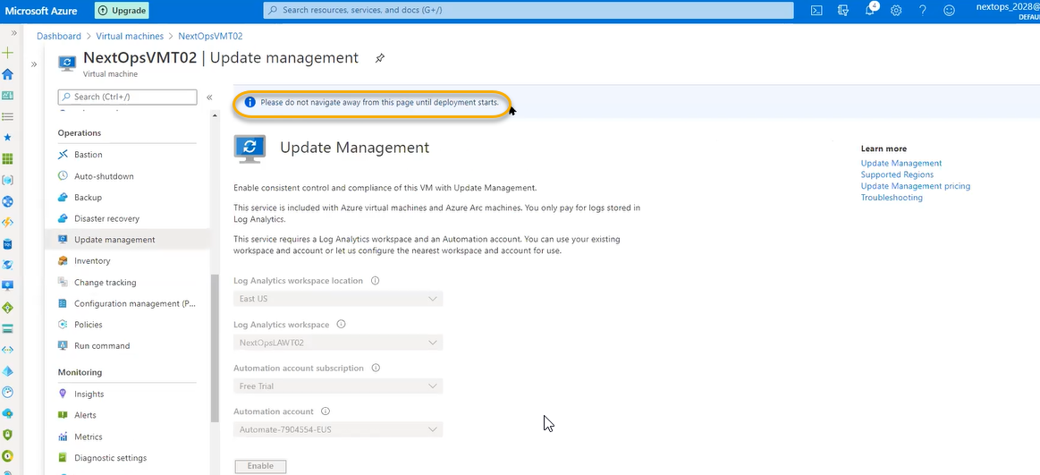

We need to create an automation account along with log analytics work space in update management source

Microsoft monitoring agent sends total information if we enable the above for that information if we need to schedule the patching/ run the patches or updates internally it will possible through Automation account

Click on the enable

Once it is enabled there will be initial scan running here if any one of the patch is missing it will show the patch number it will also aks at what you will reboot

If we configure to patch on weekends it will do accordingly

Why it is 15 minutes it is installing Microsoft agent in extensions page and also we need to wait 10 minutes after successful deployment to scan the patches if anything is missing

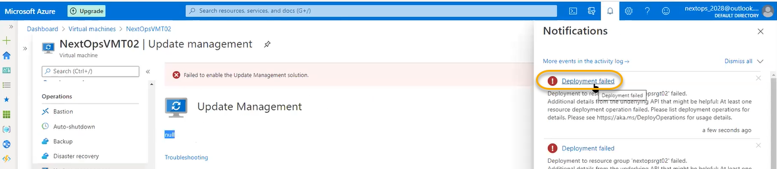

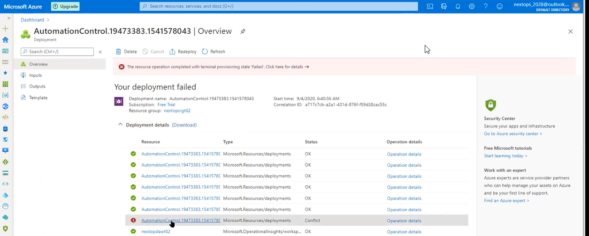

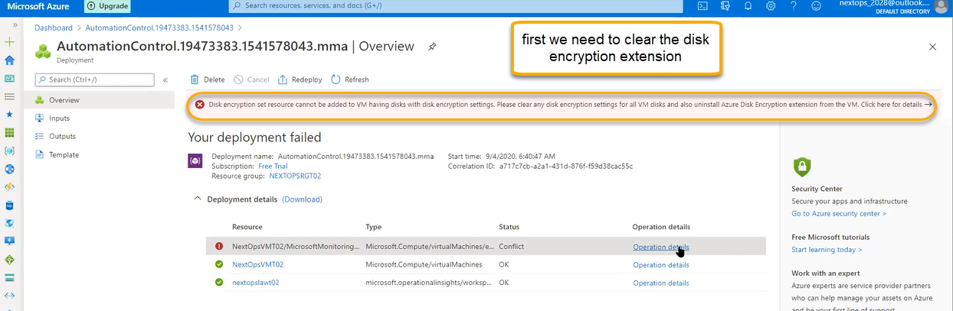

After successful deployment it will show below

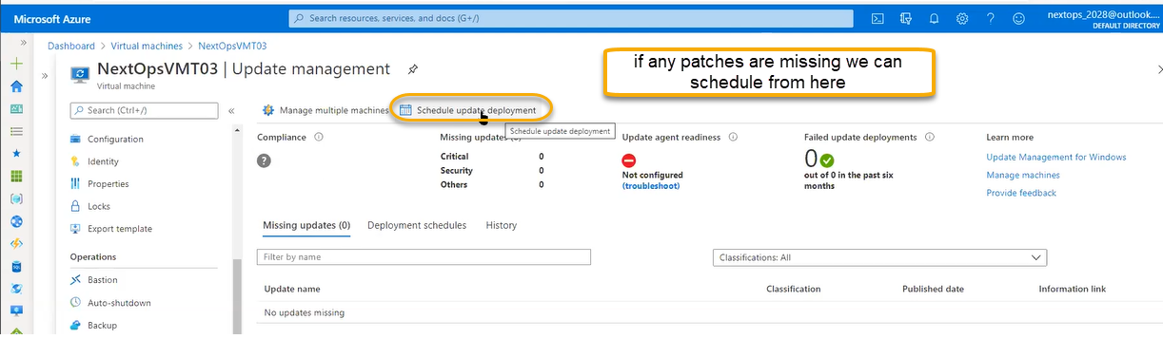

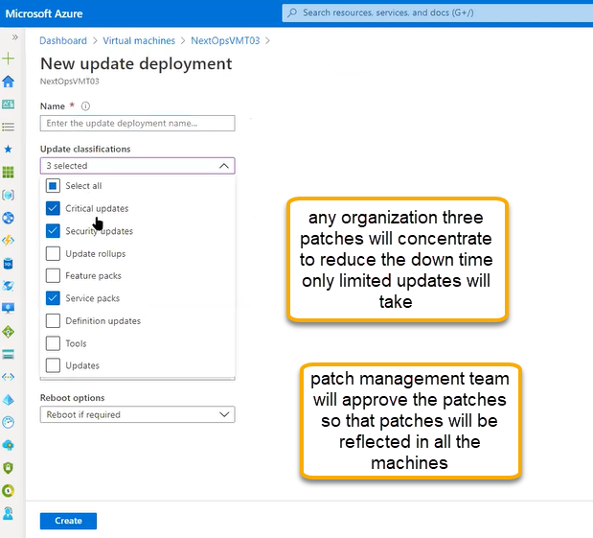

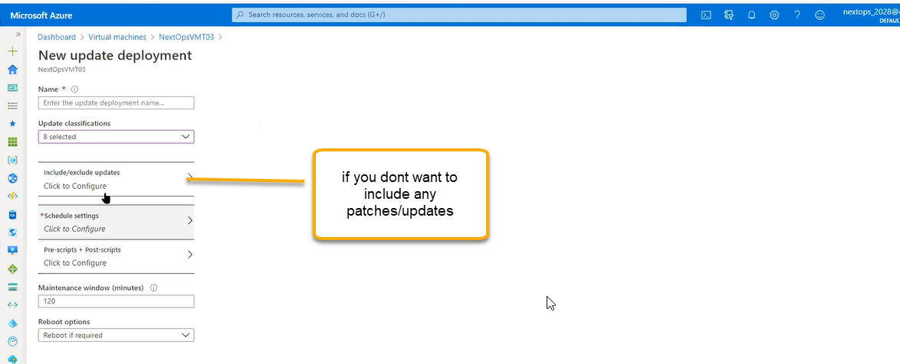

For every patching there will be articles if we mention article number then we can include or exclude the patches

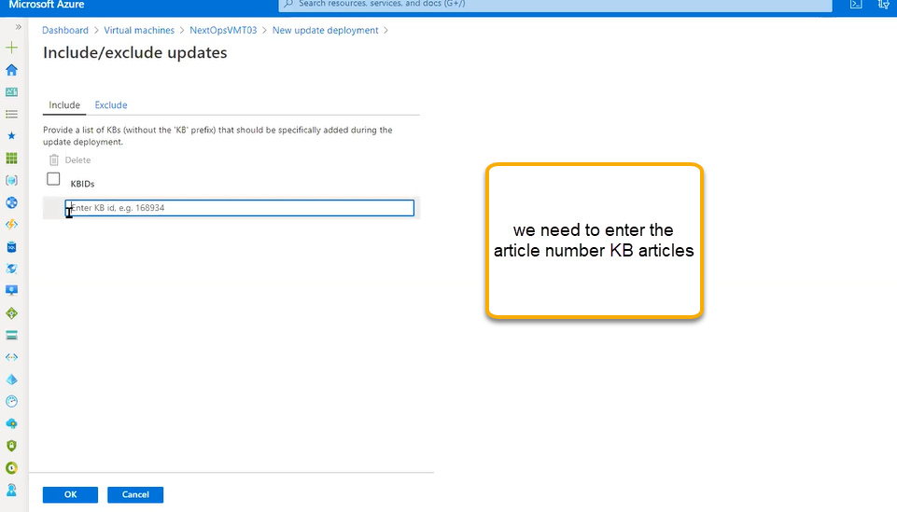

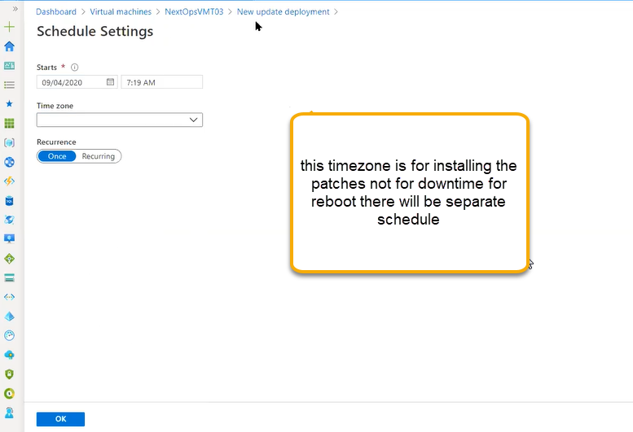

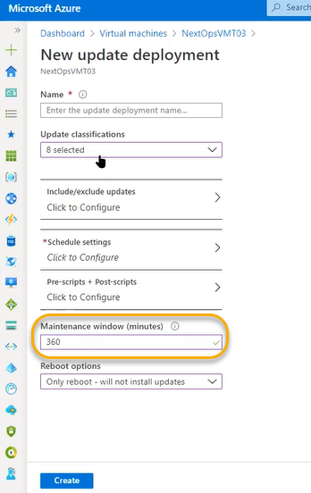

The below screenshot is navigation to automation account

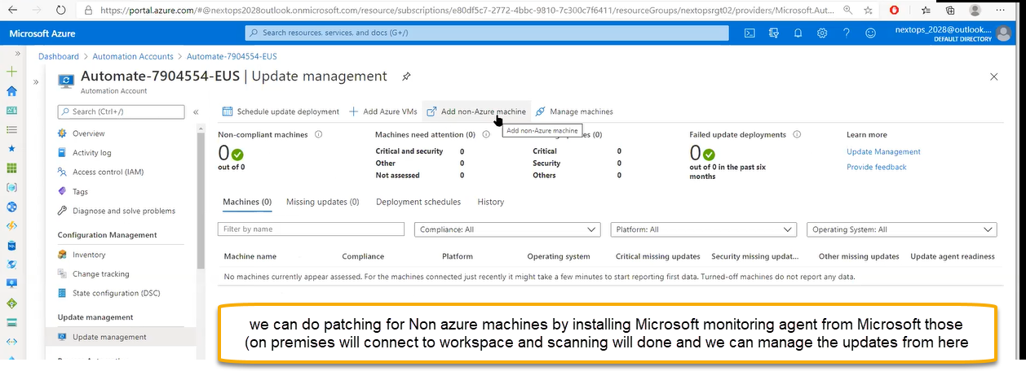

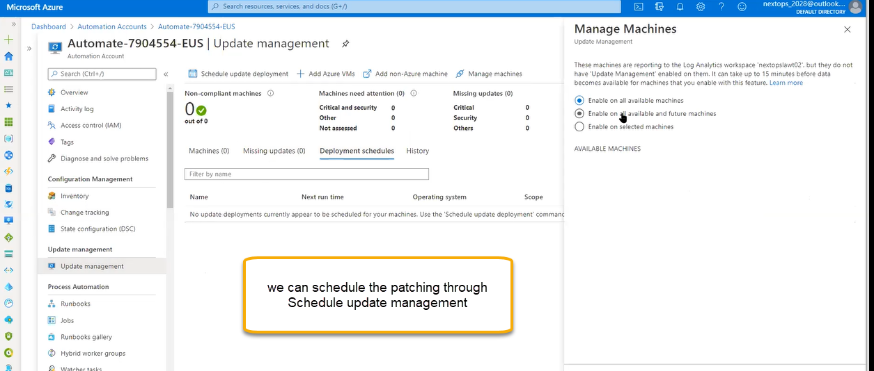

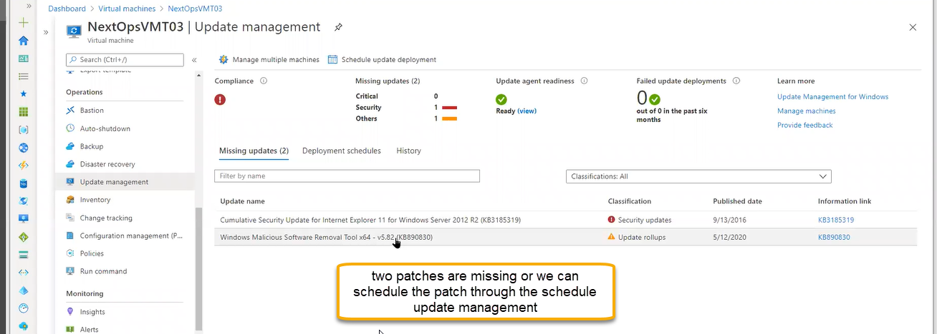

SCEM(System center configuration management) will do similar functionality

Inventory

Inside the machine which software’s, Patches how the configuration is done, are installed it will show in the inventory in detail it will show

Which files are modified?

Once you enable the inventory it will take 24 hours to reflect the data in the inventory module

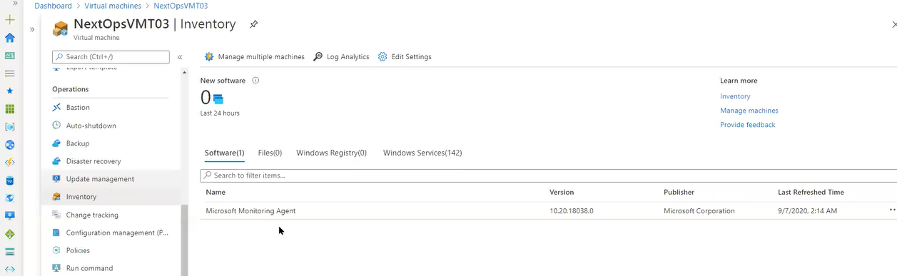

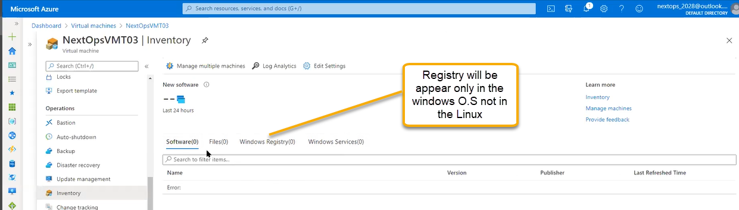

Change Tracking

Once you enable the change tracking it will take 24 hours to reflect the data in the change tracking module

Once Patch is installed it will update the O.S through files. O.S file will update to latest version. Once the patch is installed how many files have been updated/ modified that end-to-end information we can see in change tracking

Is similar to Inventory

From previous state to today’s state which changes are done in system register level changes and file level changes service level and software level changesit will show in the list

Inventory and change tracking depend on each other

After patching is done in machine system is still NOT UP we can check the files

